**Use Case “Place Order”**

1. **Use case code**

UC001

1. **Brief Description**

In the AIMS Project, UC “Place Order” describes the interaction between customers and AIMS software when the customer wishes to place order. Naturally, from the use case diagram, we describe how the use case starts and ends to gain the purpose of an use-case, and we may think of a basic flow of the events for UC “Place Order” as follows.

1. **Actors**
   1. **Name of Actor 1: Customer**
2. **Preconditions**

**There is an active network connection to the Internet.**

1. **Basic Flow of Events**
2. The customer request to place order in the view cart screen
3. The AIMS software checks the availability of products in the cart
4. The AIMS software displays the form of delivery information
5. The customer enters and submits delivery information
6. The AIMS software check the validity of delivery information
7. The AIMS software calculates shipping fees
8. The AIMS software displays the invoice
9. The customer confirms to place order
10. The AIMS software calls UC “Pay order”
11. The AIMS software save order
12. The AIMS software makes the cart empty
13. The AIMS software displays the successful order notification.
14. **Alternative flows**

Table 1-Alternative flows of events for UC Place order

|  |  |  |  |  |
| --- | --- | --- | --- | --- |
| **No** | **Location** | **Condition** | **Action** | **Resume location** |
|  | At Error!  Reference  source not  found. | If there is media of which  quantity in the stock is less  than the ordered quantity | * The AIMS software asks   customer to update the cart.   * The customer updates the cart. | Resumes  at Step 2 |
|  | At Step 3 | If Customer prefer to place a rush order | * Insert use case “Place rush Order” | Resumes at the Step 4 |
|  | At Step 5 | If a mandatory field is left  bank | * The AIMS software asks the customer to fill all the mandatory   blank. | Resumes at Step 3 |
|  | At Step 5 | If the phone number is  invalid | * The AIMS software asks the customer to enter a valid phone number. | Resumes at Step 3 |

1. **Activity diagrams**

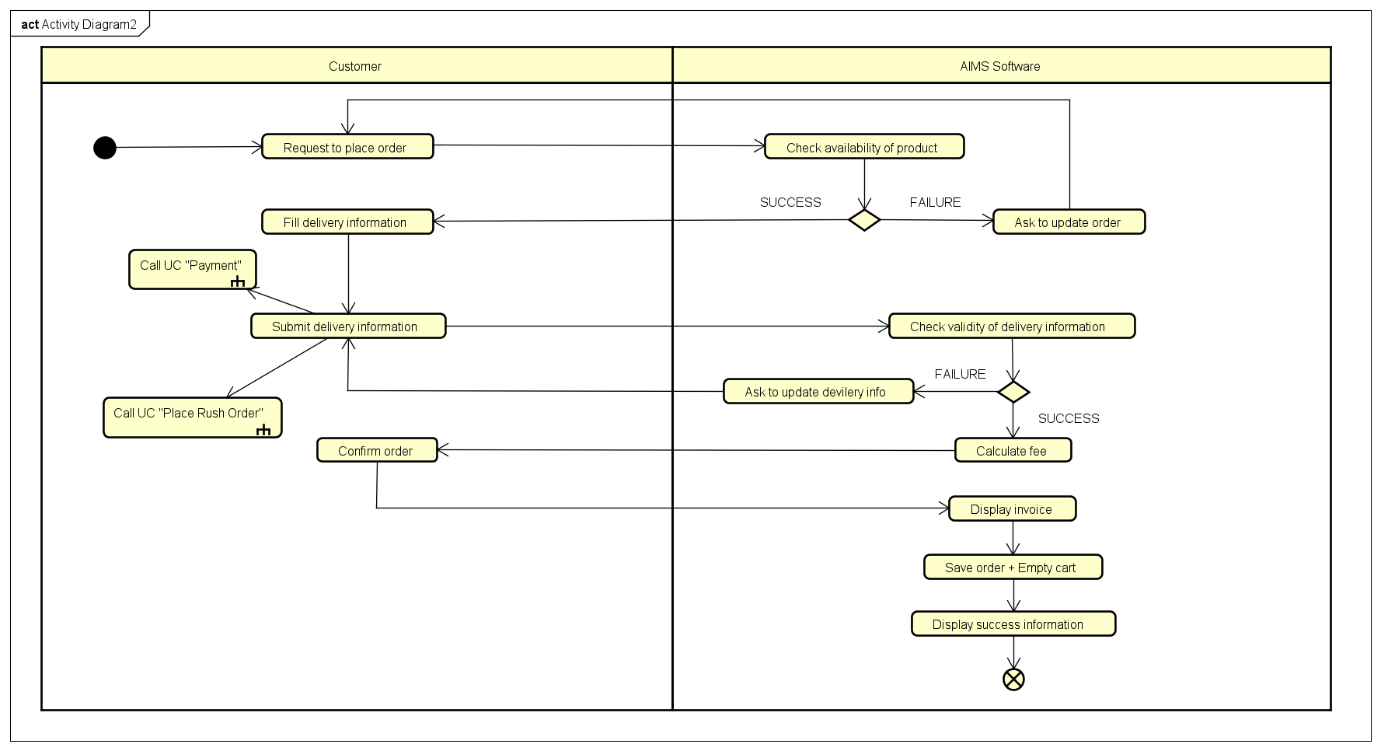

1. **Input data**

Table 2-Input data of delivery information

|  |  |  |  |  |  |
| --- | --- | --- | --- | --- | --- |
| **No** | **Data fields** | **Description** | **Mandatory** | **Valid condition** | **Example** |
|  | Receiver Name |  | Yes |  | Dao Duc Manh |
|  | Phone Number |  | Yes |  | 0913060752 |
|  | Province | Choose from list | Yes |  | Ha Noi |
|  | Address |  | Yes |  | 396 Truong Dinh Street, Hoang Mai, Ha Noi |
|  | Shipping instructions |  | No |  |  |

1. **Output data**

Table 3-Output data of displaying invoivce

|  |  |  |  |  |
| --- | --- | --- | --- | --- |
| **No** | **Data fields** | **Description** | **Display format** | **Example** |
|  | Title | Title of a media product |  | DVD Phim Vượt  ngục |
|  | Price | Price of the corresponding media product | * Comma for thousands separator * Positive integer * Right alignment | 123,000 |
|  | Quantity | Quantity of the corresponding media | * Positive integer * Right alignment | 2 |
|  | Amount | Total money of the corresponding media | * Comma for thousands separator * Positive integer * Right alignment | 246,000 |
|  | Subtotal  Before VAT | Total price of products in the cart before VAT | * Comma for thousands separator * Positive integer * Right alignment | 2,106,000 |
|  | Subtotal | Total price of products in the cart with VAT | 2,316,600 |
|  | Shipping fees |  | 30,000 |
|  | Total | Sum of subtotal and shipping fees | 2,346,600 |
|  | Currency |  |  | VND |
|  | Name |  |  | Dao Duc Manh |
|  | Phone  number |  |  | 0913060752 |
|  | Province | Choose from a list |  | Ha Noi |
|  | Address |  |  | 396 Truong Dinh Street, Hoang Mai, Ha Noi |
|  | Shipping  instructions |  |  |  |

Table 4-Output data of displaying cart

|  |  |  |  |  |
| --- | --- | --- | --- | --- |
| **No** | **Data fields** | **Description** | **Display format** | **Example** |
| 1 | Title | Title of a media product |  | CD Em về tinh khôi – Hà Trần |
| 2 | Price | Price of the corresponding media product | * Comma for thousands separator * Positive integer * Right alignment | 120,000 |
| 3 | Quantity | Quantity of the corresponding media | * Positive integer * Right alignment | 2 |
| 4 | Amount | Total money of the corresponding media | * Positive integer * Right alignment | 240,000 |
| 5 | Subtotal Before VAT | Total price of products  in the cart before VAT | * Comma for thousands separator * Positive integer * Right alignment | 2,106,000 |
| 6 | Subtotal | Total price of products  in the cart after VAT | 2,316,600 |
| 7 | Currency |  |  | VND |

**10. Post conditions**

**The logs have been updated accordingly**

**#-------------------------------------------------------------------------------------------#**

**Use Case “Place Rush Order”**

1. **Use case code**

UC003

1. **Brief Description**

In the AIMS Project, UC “Place Order” describes the interaction between customers and AIMS software when the customer wishes to place a rush order. A basic flow of the events for UC “Place Rush Order” as follows.

1. **Actors**
   1. **Name of Actor 1: Customer**
2. **Preconditions**

**Customer is in main flow “Place order” and have finish form of delivery information, selecting rush order choice.**

1. **Basic Flow of Events**
2. Customer select place rush order in delivery form
3. AIMS Software checks if there is media and the shipping address that are supported to place rush order
4. The software displays the screen for rush order
5. Customer to update rush order information
6. The software changes the formula to calculate the shipping fees
7. Return to step 6 of use case “Place order”.
8. **Alternative flows**

Table N-Alternative flows of events for UC Place order

|  |  |  |  |  |
| --- | --- | --- | --- | --- |
| **No** | **Location** | **Condition** | **Action** | **Resume location** |
|  | At Step 2 | If here is no support either from any media or the shipping address | * software would notify the customer * Software ask the customer to update delivery information | Resumes at Step 2 |
|  | At Step 4 | If the input is valid | * Software would ask the customer to update the input | Resumes at Step 4 |

1. **Activity diagrams**

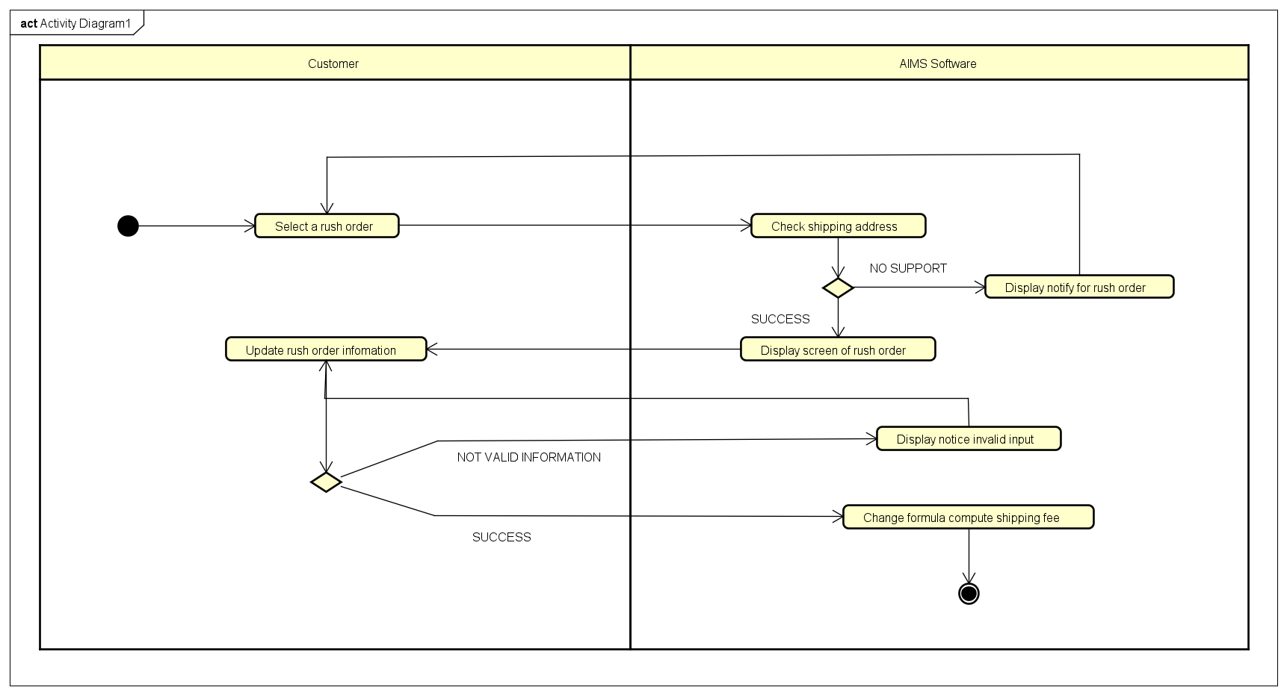

1. **Input data**

Table A-Input data of Rush order information

|  |  |  |  |  |  |
| --- | --- | --- | --- | --- | --- |
| **No** | **Data fields** | **Description** | **Mandatory** | **Valid condition** | **Example** |
|  | **delivery information** | delivery information for rush order | Yes |  |  |
|  | **delivery**  **instructions** | delivery  instructions for rush order | No |  |  |
|  | **expected delivery time interval** | expected delivery time interval for rush order | No | Time format | 15:30 Monday 11 Oct, 2021 |

1. **Output data**

Table B-Output data of …

|  |  |  |  |  |
| --- | --- | --- | --- | --- |
| **No** | **Data fields** | **Description** | **Display format** | **Example** |
|  |  |  |  |  |

1. **Postconditions: None**